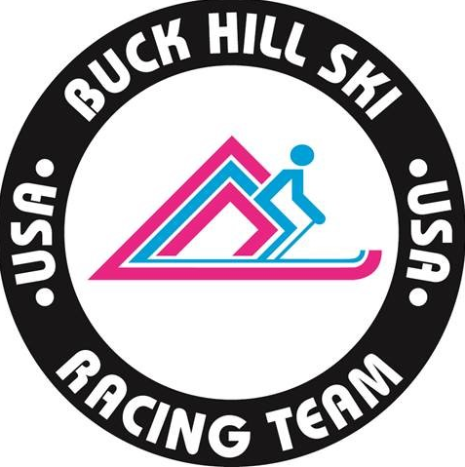

Buck Hill Ski Racing Team Copper Training Projects

Slalom October 28th – 31st

GS November 2nd– 5th

Buck Hill Ski Racing Team is kicking off the fall training season at Copper Mountain with two pre-season highly focused training projects. Team and non-team travel will be offered for both projects. Team travel is available for U14 and older athletes. It is highly recommended that U16 and U18+ athletes participate in team travel. Travel dates and schedule are listed below.

**Registration Links:**

**Copper SL Link:**[**https://go.teamsnap.com/forms/388054**](https://go.teamsnap.com/forms/388054)

**Copper GS Link:**[**https://go.teamsnap.com/forms/388069**](https://go.teamsnap.com/forms/388069)

**Staff:** Dave Ziemer (U16 Head Coach), Mark Halvorson (U12 Head Coach), Matt Hoffman (U14 Head Coach), Teagan Olin (U18/FIS Head Coach), Westminster Pace Athletes

**Flight Information (Team Travel):**

October 27th – Slalom Project Travel Day. Flight DL1137 Depart 2:28PM

October 31st – Slalom Project Travel Day. Flight DL1130 Depart 4:49PM

Confirmation JKY7MZ

November 1st – GS Project Travel Day. Flight DL1137 Depart 2:28PM

November 5th – GS Project Travel Day. Flight DL1519 Depart 4:00PM

Confirmation JKZ76T

**Transportation:**

Team travel to and from the airport via Epic Shuttles is included in the price of each project. Athletes are responsible for purchasing their own airfare.

**Camp Description:** The focus of these two camps is to work on technical skills and fundamentals of position, balance, movement and touch & fell on snow. Athletes will work in small, focused training groups within their age groups accompanied by pace and coaching staff free skiing/drills, drill courses and gate training over the course of two four-day double sessions of skiing. Training projects are being offered to experienced U12s and U14s as well as the U16 and U18+ athletes. The training environment will consist of dedicated lanes for both scored and non-scored age groups. Athletes attending both sessions will have a rest and activities day supervised by coaching staff.

**Lift Passes**

Copper’s projected opening date for the public is November 13th. Prior to this date all hill access requires appropriate training lift passes. There is a significant discount for IKON pass holders. See below for pricing structure. Lift passes will be in addition to the camp project fee.

Lift tickets are not an option this year. Early Season passes for October through Nov 13th is the only option.  See below list for details.

Adult athlete 18+ ($569.00)

Teen Athlete 13-17yrs ($419.00)

Child Athlete 5-12yrs ($299.00)

Athlete Pre-Season Pass IKON ($149.00)

(Copper pre-season pass to IKON Pass holders only valid Oct 20 – Nov 12)

Club has removed this part of the registration fee.  Below is a link for registration as well as a link to sign up for the Pre-Season Pass. Based on your plans for Copper and Winter Park camps, decide if having an Ikon pass is worthwhile or not for you this year. The club has done their best with the price of the pre-season pass to accommodate this.

**Team Travel Cost:** $1,100 (early registration 8/15 – 8/31) includes the following:

* Lodging
* Lane space
* Transportation to/from airport
* Coaching
* Video
* Dryland
* Access to NCAA pace athletes
* Full meal plan including breakfast/lunch/dinner (except during travel)

**Non-Team Travel Cost:** $700.00 (early registration 8/15 – 8/31) includes the following:

* Lane space
* Lane fee
* Coaching
* Dryland
* Video
* Access to NCAA pace athletes

**Registration/Payment Deadline:** Registration is open to Buck Hill athletes only until August 31st. Guests will be invited to register as of September 1st.

**Regular Registration:** Registration will be open from September 1st – September 30th for both members and non-members at the following rates:

**Members:** $1,200.00 Team Travel/$800.00 Non-Team Travel

**Non-Members:** $1,350.00 Team Travel/$950.00 Non-Team Travel

**Cancellation Policy:** Buck Hill Ski Team reserves the right to cancel this camp at any time prior to the first on snow day due to snow coverage, low participation, Copper Resort restrictions, the State of CO travel and restriction policies or any other safety or health concerns. Full refunds for the total registration fee will be reimbursed at that time.

**Camp Notes:** We have double session lane training booked daily except for the last day of training of each session. October 31st and November 5th will be a single session of training to accommodate travel. There will be daily video review with the athletes each day after training except for Sunday. Video from Sunday’s training will be shared via the Google folder.